Dynamic Programming:
An Analytical Approach to Algorithmic Efficiency

Introduction

Dynamic programming is a methodical approach used in algorithmic strategy to solve complex problems by breaking them down into simpler sub-problems. This technique, which can be likened to solving a complex puzzle by first methodically arranging and solving the border pieces, enables a more efficient and systematic resolution than tackling the problem in its full complexity all at once. By storing the solutions to these sub-problems, dynamic programming avoids the redundancy of recalculating them, thereby significantly reducing the computational workload.
Its importance in computer science cannot be overstated. In an era where optimal performance and resource utilization are paramount, dynamic programming offers a beacon of efficiency. It is particularly instrumental in optimization problems, where the objective is to find the best solution from a set of feasible solutions. From simple day-to-day applications to complex industrial and scientific computations, dynamic programming serves as the backbone for ensuring that tasks are completed in the most efficient manner possible.
Indeed, the adoption of dynamic programming transcends mere preference, becoming a necessity in certain situations. When faced with problems characterized by a vast number of possible solutions, many of which may overlap, dynamic programming provides a structured framework to navigate through these possibilities. It has proven to be an indispensable tool in the arsenal of computer scientists, economists, engineers, and researchers across various fields.
The thesis of this discussion posits that dynamic programming is not just a technique but a vital paradigm that simplifies complex problems by decomposing them into more manageable sub-problems. This decomposition is not merely a convenience but a strategy that optimizes computational efficiency and resource management. In essence, dynamic programming transforms the intractable into the tractable, the unsolvable into the solvable.
As we delve deeper into the nuances of dynamic programming, it becomes evident that its utility is rooted in its dual ability to enhance precision in problem-solving and to do so with a frugality of computational resources. This introduction lays the groundwork for a comprehensive exploration of dynamic programming, an exploration that will highlight its principles, applications, and immense potential in contemporary computing and beyond.

The Conceptual Framework of Dynamic Programming

The inception of dynamic programming is attributed to the ingenuity of mathematician Richard Bellman in the 1950s. Originally developed as a mathematical optimization method, it was Bellman's work that laid the foundations for what would become a pivotal strategy in the realm of computation and beyond. The evolution of dynamic programming has been characterized by its expanding applications, from its initial use in operations research and economics to its current widespread use in various fields including bio-informatics, control theory, and artificial intelligence.
At the core of dynamic programming lies the principle of Overlapping Sub-problems. This principle observes that many complex problems are composed of smaller, recurring problems. By solving these smaller problems once and storing their solutions – typically in an array or hash table – dynamic programming algorithms avoid the computationally expensive task of solving them each time they occur. This is akin to a person climbing a staircase and marking each step with a note of the effort taken to reach that point; if they need to climb the same staircase again, they can conserve energy by referring to these notes instead of recalculating their effort for each step.
Equally critical to dynamic programming is the concept of Optimal Substructure. This concept asserts that an optimal solution to a problem contains within it optimal solutions to sub-problems. For example, in a shortest path problem, the shortest path to a point includes within it the shortest path to intermediate points. This characteristic is what enables dynamic programming to build up the solution to a complex problem using the solutions to smaller problems.
Implementing dynamic programming can be achieved through two main approaches: Memoization and Tabulation. Memoization is a top-down approach where the algorithm starts solving the problem by first tackling it at a high level and then breaking it down into sub-problems, which are solved recursively and the results stored for future reference. Tabulation, on the other hand, is a bottom-up approach where the algorithm first solves all the small sub-problems and then combines them to solve larger sub-problems. This method iteratively builds up the solution by filling in a table, usually a multidimensional array, where each cell represents a sub-problem with its solution.
Both approaches have their merits and demerits. Memoization is straightforward to code and maintains a natural problem-solving structure similar to recursion, but it can lead to a larger memory footprint and stack overflow in cases with deep recursion. Tabulation eliminates the risk of stack overflow and can be more space-efficient, but it may compute solutions for sub-problems that are never used by the main problem. The choice between the two often depends on the specific problem at hand, and in some instances, a hybrid approach may be employed to leverage the strengths of both.
Understanding these foundational elements of dynamic programming is essential for grasping its power and flexibility. As we will see in subsequent sections, the effective application of dynamic programming principles can dramatically improve the performance and efficiency of algorithms across a multitude of problem domains.

Mechanics of Dynamic Programming

To understand the significance of dynamic programming in practice, consider the recursive tree of the Fibonacci Sequence:
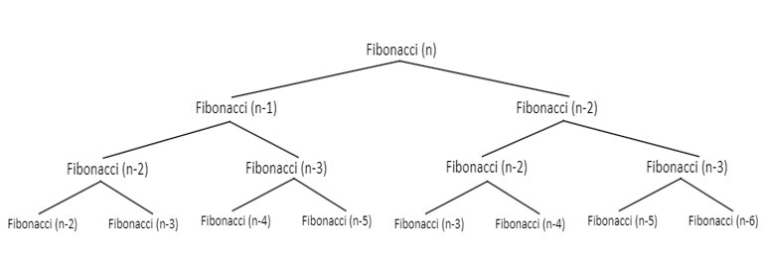

As seen, most function calls are repeated with identical arguments; the function calls in the Fibonacci Sequence are redundant. For instance, Fibonacci(n-2) will produce the same result on the right of the tree as it will on the left of the tree. This redundancy can be eliminated by implementing dynamic programming to store the results of such function calls.

Dynamic programming will achieve this by storing the result of the Fibonacci calls in an array. On each Fibonacci call, the program will check if the same arguments were used in a previous Fibonacci call by searching the array.

As an example, consider the Fibonacci Sequence for 5 as shown in the diagram below:

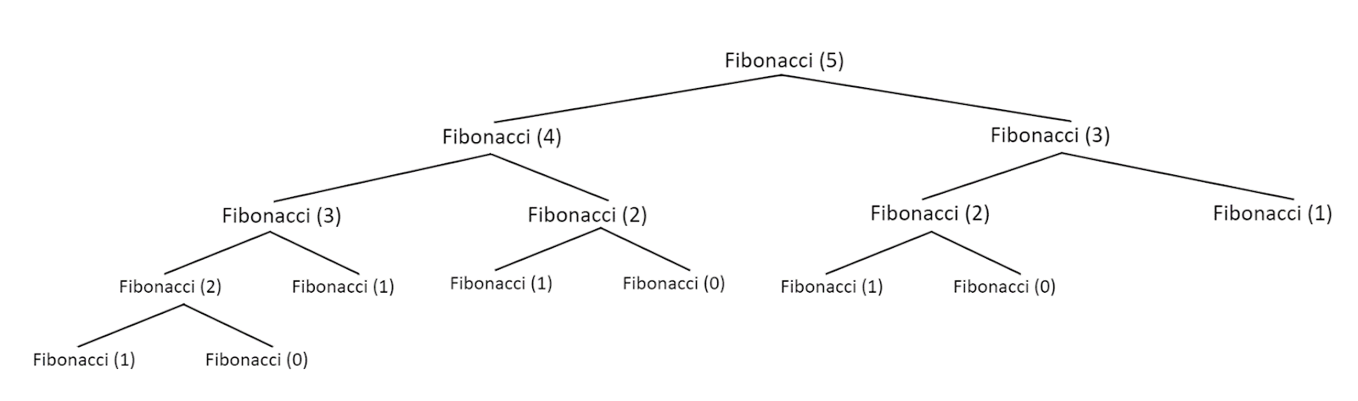
This tree representation does not represent an implementation that makes use of dynamic programming since redundant function calls exist such as duplicate calls of Fibonacci(3).
Due to the program’s recursive structure, the calls on the right will be executed before the calls on the left. Thus, in this instance, when dynamic programming is implemented, the right side of the tree will be eliminated, along with certain sub-branches of the left tree. Below is the completed representation of the recursive tree of the Fibonacci Sequence with dynamic programming utilized:
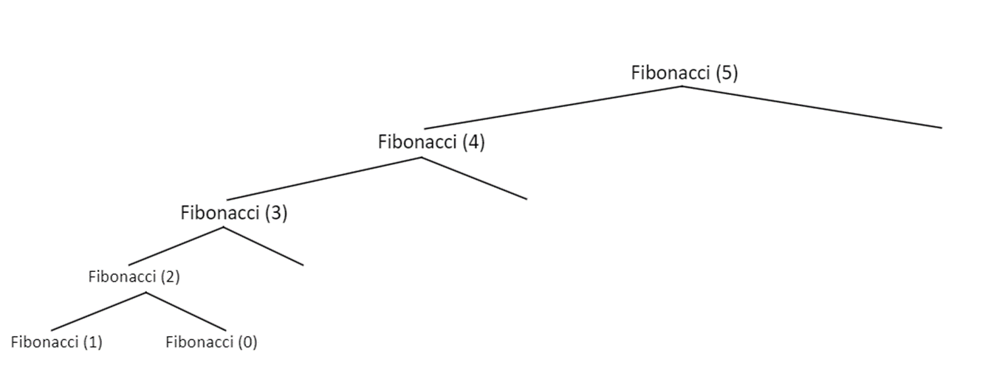
In the original recursive tree, the number of calls to Fibonacci() is fifteen. When dynamic programming is utilized, the number of calls is reduced to six. Therefore, it is demonstrated that implementing dynamic programming greatly reduces the time complexity of a program. For instance, the Fibonacci Sequence implemented without dynamic programming is O(2n); with dynamic programming implemented, the complexity is reduced to O(n).

Implementation of Dynamic Programming

Consider the pseudocode for the Fibonacci Sequence using recursion without dynamic programming:
FUNCTION fibonacci(n)
IF n <= 1 THEN
RETURN n
RETURN fibonacci(n-1) + fibonacci(n-2)

This program recursively calls fibonacci twice and adds the result (one for the number subtracted by 1, the other for the number subtracted by 2). This recursively continues until the number equals to 1 or 0 in which case the number is returned (the base case). As demonstrated in the Mechanics of Dynamic Programming portion of this paper, this implementation includes redundant calls to fibonacci. To implement dynamic programming, we will include an array to store the previous results of the function calls (sub-problems) and check if the sub-problem has already been solved before recursively calling fibonacci again.

FUNCTION fibonacci(n, array)
IF n <= 1 THEN
RETURN n
// Check if the sub-problem has already been solved.
IF array[n] THEN
RETURN array[n]
// If the sub-problem has not already been solved.
ELSE
// Adding the sub-problem to the array.
// Use the index of the array to identify the sub-problem.
array[n] = fibonacci(n-1, array) + fibonacci(n-2,array)
RETURN array[n]

By storing the result of the sub-problems in an array and retrieving them when necessary, this dynamic programming implementation greatly reduces the time complexity of the Fibonacci Sequence.

Advanced Concepts and Variations in Dynamic Programming

As the discourse on dynamic programming advances, it is imperative to explore the sophisticated techniques that cater to the intricacies of real-world problems. Advanced dynamic programming techniques such as Stochastic Dynamic Programming (SDP) and Approximate Dynamic Programming (ADP) extend the classic principles of dynamic programming to more complex and uncertain environments.
Stochastic Dynamic Programming is an extension of traditional dynamic programming that incorporates elements of randomness and probability. While classical dynamic programming assumes a deterministic world, SDP deals with scenarios where outcomes are not certain, and decisions must be made in the context of this uncertainty. This technique is especially relevant in fields like finance and operations research where future states of the world are uncertain, and decisions must be based on the likelihood of various outcomes. SDP evaluates not just the immediate rewards of a decision but also its expected future rewards, taking into account the probability of various possible future states.
Approximate Dynamic Programming, on the other hand, is employed when the state space is too large to handle explicitly, as is often the case with real-time decision-making systems or complex resource allocation problems. ADP uses approximation methods to find solutions that are close to optimal. Techniques such as value function approximation or policy approximation help in managing the vastness of the state space, allowing for near-optimal solutions without exhaustive enumeration of every possible state.
The challenge of multi-dimensional dynamic programming problems arises from the "curse of dimensionality," where the number of possible states grows exponentially with the number of variables in the problem. In such cases, dynamic programming must be carefully crafted to manage this exponential growth. This might involve sophisticated state aggregation techniques, where similar states are grouped together, or the use of hierarchical dynamic programming, which breaks the problem down into a hierarchy of sub-problems.
Furthermore, the integration of dynamic programming with other algorithmic paradigms has led to a powerful synergy that can tackle a wide array of problems. For instance, dynamic programming has been combined with greedy algorithms to create efficient heuristics for problems where a purely greedy approach would fall short. In machine learning, dynamic programming techniques underpin reinforcement learning algorithms where an agent learns to make a sequence of decisions that maximize some notion of cumulative reward.
In computational biology, dynamic programming has been effectively paired with sequence alignment algorithms, leading to significant breakthroughs in genomics. Likewise, in operations research, dynamic programming's integration with integer programming has optimized complex decision-making processes across industries.
The fusion of dynamic programming with other paradigms is not merely additive but often multiplicative in its effect on problem-solving capabilities. By leveraging the strengths of dynamic programming, such as its meticulous problem decomposition and sub-problem optimization, and combining these with the specific advantages of other methods, these hybrid algorithms represent some of the most advanced tools in algorithmic and computational research.
As we march into an era dominated by data and complexity, advanced dynamic programming techniques and their integration with other paradigms stand at the forefront of algorithmic innovation. They offer a beacon of hope for solving the next generation of problems, which are characterized by vast data sets, complex decision spaces, and the need for real-time processing and decision-making.

Conclusion

Throughout this exploration, we have seen how dynamic programming serves as a critical technique for conquering complex problems across the computational landscape. From its foundational principles to its application in a variety of contexts, dynamic programming has shown itself to be an indispensable part of the problem-solver's toolkit, enabling efficiency and innovation in equal measure.
We have traced the historical lineage of dynamic programming, acknowledging Richard Bellman's seminal work, and recognized how its core principles—Overlapping sub-problems and Optimal Substructure—equip us to solve large-scale problems by addressing and reassembling their smaller components.
Through examples like the Fibonacci sequence, we illustrated the tangible benefits of dynamic programming, particularly its capacity to transform computationally intensive tasks into more manageable ones. Our discussion of Memoization and Tabulation laid out the strategic considerations one must undertake when applying dynamic programming, each technique offering a pathway to solution optimization.
The exploration of Stochastic Dynamic Programming and Approximate Dynamic Programming opened a window into the future of dynamic programming—a future where its principles are applied to systems characterized by uncertainty and complexity. Moreover, the integration of dynamic programming with other algorithmic methods, such as greedy algorithms and reinforcement learning, showcases its versatility and its potential to push the envelope in fields as varied as genomics and resource management.
As we advance, the adaptability of dynamic programming will only become more critical. In the realms of artificial intelligence and machine learning, where data is plentiful and the problems are intricate, the strategies and techniques of dynamic programming will be vital. Its ability to distill complexity into clarity will remain a key driver of algorithmic progress.
In summary, dynamic programming stands as a profound contribution to the disciplines of mathematics and computer science. It is a method that not only meets the challenges of the present but is also poised to evolve with the computational demands of the future. As we continue to unlock the mysteries of data and complexity, dynamic programming will undoubtedly remain a beacon of ingenuity, guiding our way toward ever more efficient and effective solutions.

References

"MIT OpenCourseWare Lecture 19: Dynamic Programming I: Fibonacci, Shortest Paths." YouTube, uploaded by MIT OpenCourseWare, 8 Nov. 2011, www.youtube.com/watch?v=OQ5jsbhAv_M.

“Program for nth Fibonacci Number.” GeeksforGeeks, www.geeksforgeeks.org/program-for-nth-fibonacci-number/.

